#### 

#### Newsletter December 17th 2018

Dear Parents,

Sincere thanks from all at school for your support over the first term. It has been a very busy time for everyone from the first day of term with the children being involved in so many extracurricular activities including athletics, football, soccer, cricket, rugby and of course the preparations for the school plays which were once again a major success. My thanks to all of the teachers for their work in preparing teams and producing the plays, all done in addition to the day to day school work. Teachers have overseen standardised testing, parent teacher meetings and to top it all off have been subjected to yet another very successful inspection. All this has taken place in just one term.

I would like to thank the parents for their attendance and to congratulate our pupils on their performances in our end of term plays. These are a very important facet of our school year and draw together much of our music, PE and drama curriculum over the first term. It is essential that all pupils participate in these productions into the future as the subjects entailed are given the same status as any other school subject therefore opt out of the school work involved will not be entertained in the future.

***1*** **End of Term**

School will close for the Christmas break tomorrow (Friday 20th December) @ **12.00pm**. Please ensure that children are collected at this time. The school will reopen on **Monday 6th January 2020** at the usual time.

**2** **Text Alerts /Contact Details**

Please ensure that all phone numbers and contact details are correct and up to date. As we are increasingly using text message as a means of communication it is vital that we have correct contact details. Our ICT system gives feedback on text messages sent including where these have not been delivered due to incorrect or changed numbers. This has been a cause of some frustration over the last week or so when we have been unable to contact parents/guardians of children requiring collection due to illness.

Finally on behalf of everybody at Scoil Íosa, we wish you all a very Happy Christmas and New year and look forward to welcoming you all back to school on January 6th 2020.

*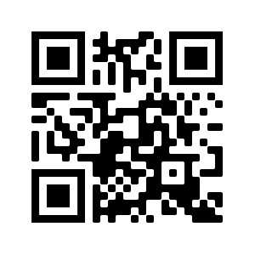With thanks for your continued help and co-operation*

Kenneth Dennedy

Abbeyquarter 094 9630310 Senior School

Ballyhaunis Web: www.iosaballyhaunis .com

Co Mayo email: [iosaballyhaunis@gmail.com](mailto:iosaballyhaunis@gmail.com)

Eir Code F35 PX94

Scoil Íosa

**“Ní neart go cur le chéile**

**(”Our strength is in our unity)**

[](http://www.google.ie/url?sa=i&rct=j&q=&esrc=s&source=images&cd=&cad=rja&uact=8&ved=2ahUKEwi0iL-5iobfAhUpJ8AKHfzSAzEQjRx6BAgBEAU&url=http://www.swaggprograms.com/awards/-news/2017/12/december-2017-newsletter-h2acr1201&psig=AOvVaw1aGyTh2OyijLBbfjPRHimX&ust=1544009666945234)



NEWSLETTER December 19th

2019